Github Faizal Alamudi
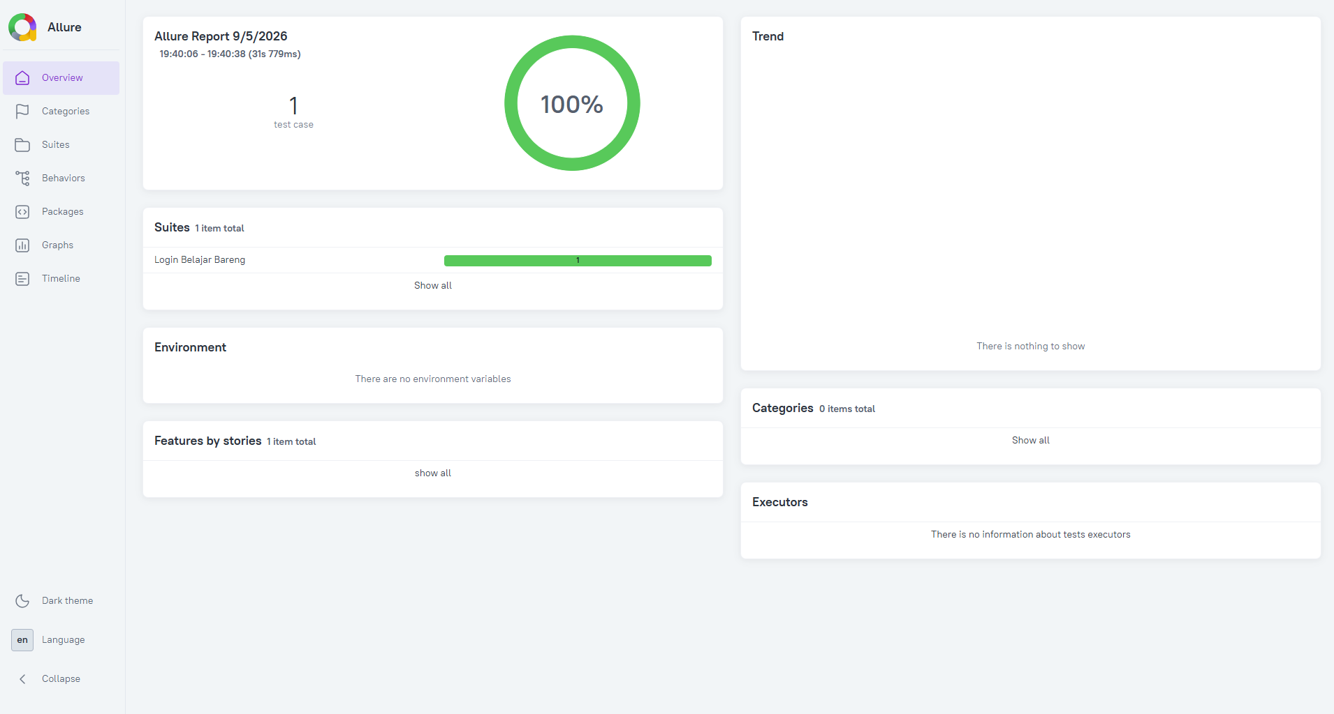
https://github.com/GITFA16/MobileTest.git
